Floyd County Head Start Birth to Five
Floyd County Community Action Agency, Inc.
PO Box 1025 New Albany, IN 47151-1025
Telephone (812) 271-4140 Fax (812) 271-4145
www.fchsbirth2five.com

Hello Parents and Families,

Due to the raising numbers of COVID-19; the following guidelines will be implemented.
For all positive cases and exposures parents are required to contact our Health Office (812-271-4140) to determine return date for child.

Positive Cases
Preschoolers (Age 3 to 5)
- COVID-19 positive individuals will continue to have a mandatory 5-day, stay-at-home isolation period, return day 6. If fever free for at least 24 hours without the use of fever-reducing medications and show improvement in symptoms
- In order to return to a school environment, positive individual cases must also wear a mask for an additional 5-day period (days 6-10). If the child is unable to mask appropriately they will be required to isolate for the full 7 days, returning on day 8.

Infants and Toddlers (up to 36 months)
- COVID-19 positive individuals will continue to have a mandatory 7-day, stay-at-home isolation period, return day 8. If fever free for at least 24 hours without the use of fever-reducing medications and show improvement in symptoms
- Infants and toddlers (up to 24 months) cannot wear a mask, as it is a hazard for them. Because masking is not an option, children in Early Head Start who test positive will need to isolate for 7 days. This time period has been shortened from 10 days to 7 days because it is unlikely that the child will spread the virus after 7 days of isolation.

For all positive cases parents are required to contact our Health Office (812-271-4140) on day 5 to update on symptoms and ensure appropriate return date.

Exposures
- Your child will not be quarantined unless they test positive for COVID-19 or have symptoms. Masks are required for ten days for age appropriate children that have been exposed.
- Any household with confirmed positive case that are unable to isolate the positive person from the student need to contact Health Office to determine an appropriate return date for student.
- Please do not send your child to school if they have any symptoms of illness (quarantine applies to symptomatic individuals and positive cases only).

We appreciate everyone’s support during this challenging time. As we have done for the past two years, we will continue to work with the Indiana Department of Health (IDOH) as well as our local Floyd County Health Department (FCHD) and adjust our future guidance and policy as needed.

Masks
Masks are optional but recommended for all staff and students when our county is considered in “High” rate of infection and spreading.
Visitors
Visitors will be based on COVID-19 Community Level.
- When Floyd County is on High level visitors will not be allowed in the building.
- When Floyd County is on Medium level visitors must complete symptom screener prior to entry into facility.
- When Floyd County is on Low level visitors are allowed in the building.

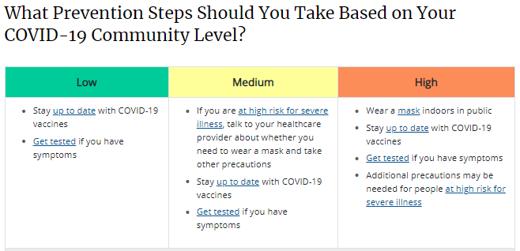

Sincerely

Tara Meachum
Director
Floyd County Community Action Agency, Inc.

